Arizona Glaucoma Specialists
Dedicated to the Medical and Surgical Management of Glaucoma

We Welcome You to Our Practice

Patient Information

Jeffrey S. Kay, M.D.,
Max C. Kim, MD.,
and Associates

“Our sight is the most perfect and most delightful of all our senses; it fills the mind with the largest variety of ideas;--converses with its objects at the greatest distance, and continues the longest in action without being tired or satiated with its proper enjoyments.”
- Joseph Addison

For more information see our website at
www.azglaucomaspecialists.com

Introduction

The ability to see and take in our surroundings through vision is a blessing. Nobody would ever wish to lose this great ability. Unfortunately, there are diseases that can rob us of the precious sense of sight. Glaucoma is one of them. Often Glaucoma has been called a “silent thief” because vision loss can be slow and unnoticeable to the person until it is too late and irreversible damage has been done. We focus on the treatment and management of Glaucoma to help prevent unnecessary loss of vision and damage to the eyes.

What to expect

Your initial examination will be scheduled in two visits with testing on the first visit and a very thorough and educational examination on the second. The testing appointment lasts about one hour and does not interfere with normal activities such as driving or work. The second visit lasts about three hours. You will be examined and probably dilated for pictures of the inside of the eyes. A video will be shown and a booklet on Glaucoma will be presented to you. You will have the opportunity to ask any questions that you may have. It is best if you come with a family member or friend that can drive after the dilated examination. Following visits will generally be shorter. Most patients with Glaucoma will need to be seen every few months to monitor the disease.

Tests performed

Tonometry – This allows the doctor to check the pressure within the eye and is measured at all of your visits. You are given a numbing drop in each eye before the test.
Ophthalmoscopy – The doctor will look at the optic nerve and determine if the nerve looks healthy or if there is any change in the nerve caused by Glaucoma. If photos need to be taken your eyes will be dilated. Dilation can last several hours and may blur your vision and make you light sensitive.
Optic Disc and Nerve Fiber Layer Analysis – Special images will be taken about every 6 months to watch for signs of progressive damage to the optic nerve.
Visual Field – Glaucoma often affects the peripheral or side vision first. The visual field test checks for any loss of peripheral vision and takes several minutes per eye.
Gonioscopy – This test allows the doctor to visualize the drainage angle of the eye. This angle is located where the cornea (front clear part of the eye) meets the iris (colored part) and is seen with a mirrored contact lens instrument.
Pachymetry – The thickness of the cornea is measured to determine the effect on eye pressure readings and the likelihood of nerve damage.

Emergencies

In case of emergency, call the office. If the office is closed when you call, you will be given a phone number to reach one of the doctors or instructed otherwise how to proceed. If you leave a message for the doctor you will be contacted as soon as possible.

Finances

If you have a co-payment with your insurance you will be expected to pay the co-payment at the time of your appointment. If your insurance plan requires a referral then you will be required to bring it to the first appointment or your insurance may refuse to pay. Please bring your insurance cards with you to all of your appointments and promptly inform us of any changes in insurance or address. For self-pay patients please call and talk with someone in Bookkeeping to make payment arrangements.

Testing Appointment
(Driver not necessary)
Date: ____________Time: ________

Consultation Appointment
(Driver recommended)
Date: ___________ Time:_________

Office Locations

6599 N. Oracle Road
Tucson, AZ 85704
Phone:(520) 544-4393
Fax: (520) 544-0098
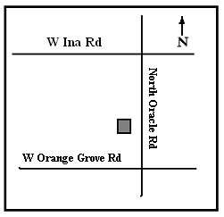

Desert Ridge Medical Campus, Bld B
20940 North Tatum Blvd Suite 250
Phoenix, AZ 85050
Phone: (480) 538-7075
Fax: (480) 538-7952
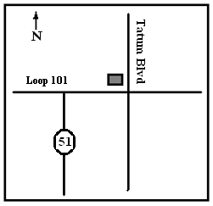

900 N. San Fransisco Street
Flagstaff, AZ 86001
Phone: (800) 405-6968
Fax: (520) 544-0098
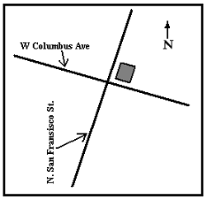

Out of town patients can call toll free:
1-800-405-6968

.

